Disaster Management System
Branch: CSE Section: 6 Batch No:15
Student Roll No’s : 24B11CS129, 24B11CS125, 24B11CS438
Student Name’s : G.P.L.Parvathi, G.Pravallika Naga Sai, T.Sai Aditya
Faculty Name : Padma Sri mam

Introduction
The Disaster Management & Emergency Alert System is a full-stack web application developed to help citizens report emergency incidents in real time and enable authorities to respond quickly and efficiently.
The system replaces manual emergency reporting methods and provides a digital platform for faster disaster response with improved:
• Safety
• Real-time communication
• Accuracy of incident reporting
• Faster emergency response
• Better coordination between citizens and authorities
This application is developed using modern web technologies:
• Frontend: React JS
• Backend: Node JS with Express JS
• Database: MongoDB (NoSQL)
• Tools: MongoDB Compass, Nodemon, NPM
The project follows a separate frontend and backend architecture executed through multiple terminals for database, server, and client.

Problem Statement
In traditional disaster management systems:
• Emergency incidents are reported manually
• Communication between citizens and authorities is slow
• There is no centralized system to track incidents
• Response time is often delayed
Due to these issues, disaster handling becomes inefficient and unorganized.
Therefore, a modern web-based Disaster Management & Emergency Alert System is required to automate:
• Real-time incident reporting
• Centralized incident tracking
• Faster emergency response

Objectives of the Project
The main objectives of the project are:
• To provide secure user authentication for citizens and authorities
• To allow users to report disaster incidents in real time
• To store and manage incident data using MongoDB
• To enable authorities to view and track reported incidents
• To update the status of incidents (Pending, In Progress, Resolved)
• To improve communication between citizens and emergency responders
• To build a scalable full-stack web application using modern technologies

Scope of the Project
The system can be used in:
• Government disaster management departments
• Emergency response teams
• Local authorities and municipalities
• Educational demonstration of MERN stack applications
The application supports:
• Citizens for reporting emergency incidents
• Authorities for monitoring, managing, and updating incident status

Modules Description
1. User Authentication Module
• Citizen registration and login
• Authority/Admin login
• Secure session or token-based authentication
• Role-based access control (Citizen / Authority)

2. Incident Reporting Module
• Submit new disaster incidents
• Provide incident type, description, and location
• Automatic date and time recording
• Store incident data in MongoDB

3. Incident Management Module
Citizen Side:
• View submitted incidents
• Check incident status updates
Authority Side:
• View all reported incidents
• Update incident status (Pending / In Progress / Resolved)
• Assign priority levels

4. Emergency Alert Module
• Display emergency notifications
• Broadcast important alerts to users
• Provide safety instructions during disasters

5. Dashboard Module
Citizen Dashboard:
• Report new incident
• View personal reports
Authority Dashboard:
• Monitor all incidents
• Filter incidents by type or status
• View summary statistics

6. Admin Control Module
• Manage user accounts
• Monitor system activity
• Maintain database records

Database Design (MongoDB)
The system uses MongoDB, a NoSQL database that stores data in JSON-like documents instead of traditional tables.
It is used to store:
• User details
• Incident reports
• Incident status updates

Advantages of MongoDB
• Flexible schema for different disaster types
• Easy storage of real-time incident data
• Faster development with MERN stack
• Scalable for large systems

Collections Used
1. Users Collection
• _id
• name
• email
• password
• role (citizen / authority)
2. Incidents Collection
• _id
• type
• description
• location
• status (Pending / In Progress / Resolved)
• createdAt
3. Alerts Collection
• _id
• title
• message
4. Notifications Collection (Optional / Future)
• _id
• user_id
• incident_id
• message
• date

System Execution Process
The MERN-based Disaster Management system runs using three terminals:
• Terminal 1: Start MongoDB server
• Terminal 2: Run backend using Nodemon
• Terminal 3: Run React frontend using npm start
MongoDB Compass is used to verify stored data.

User Interface Design
Screens Included
• Login / Registration Page
• Citizen Dashboard (Report Incident, View Status)
• Incident Reporting Page
• View Incidents Page
• Authority Dashboard
• Incident Management Page (Update Status)
• Emergency Alerts Page
• Admin Panel (User Manage
These are the files which shows the work of frontend and backend:
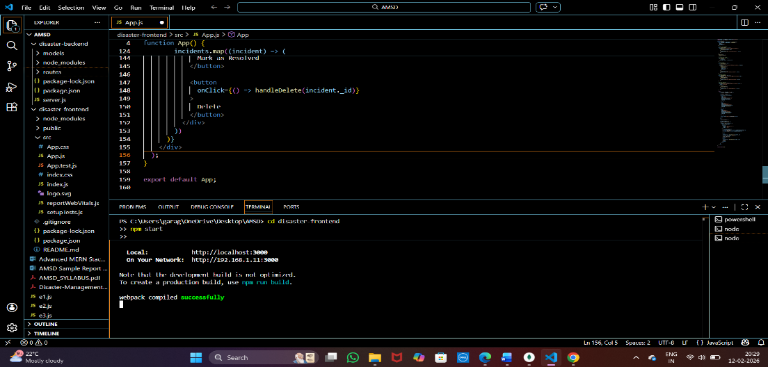
The page showing the disaster details to be entered:
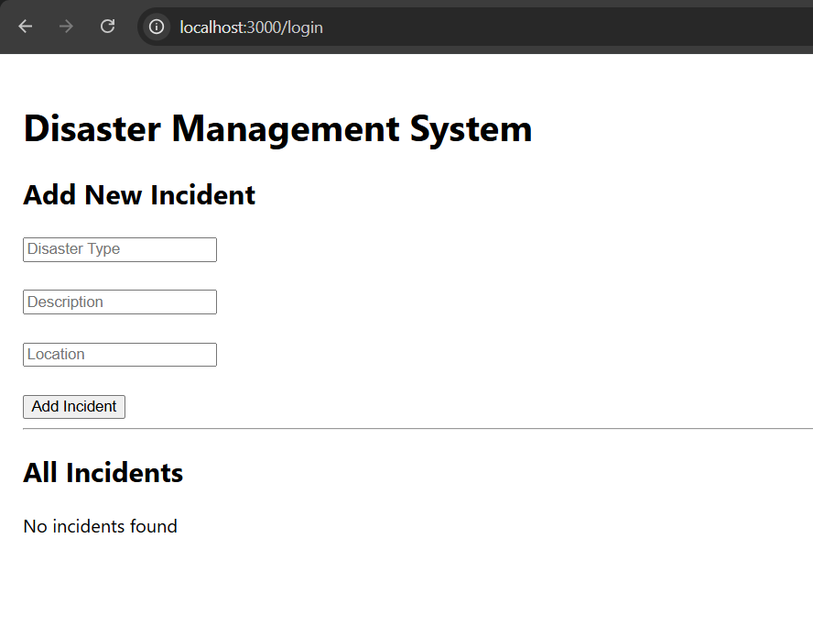

UI after adding details of a disaster:
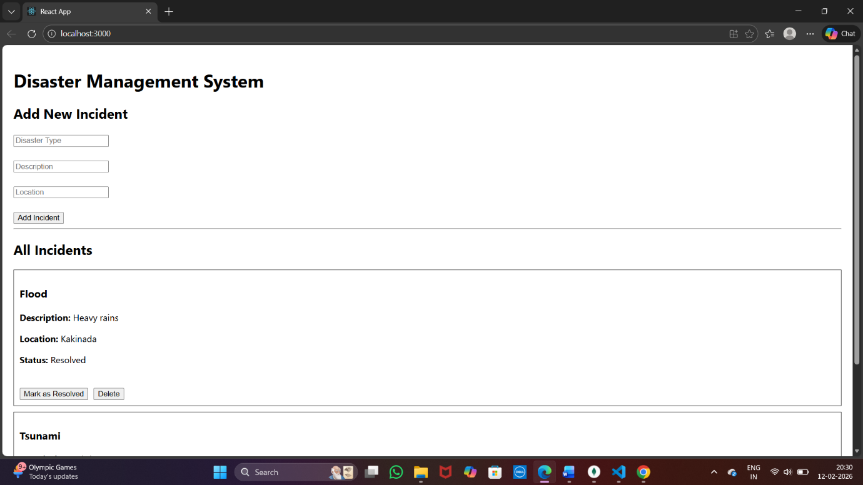

Mongodb connection:
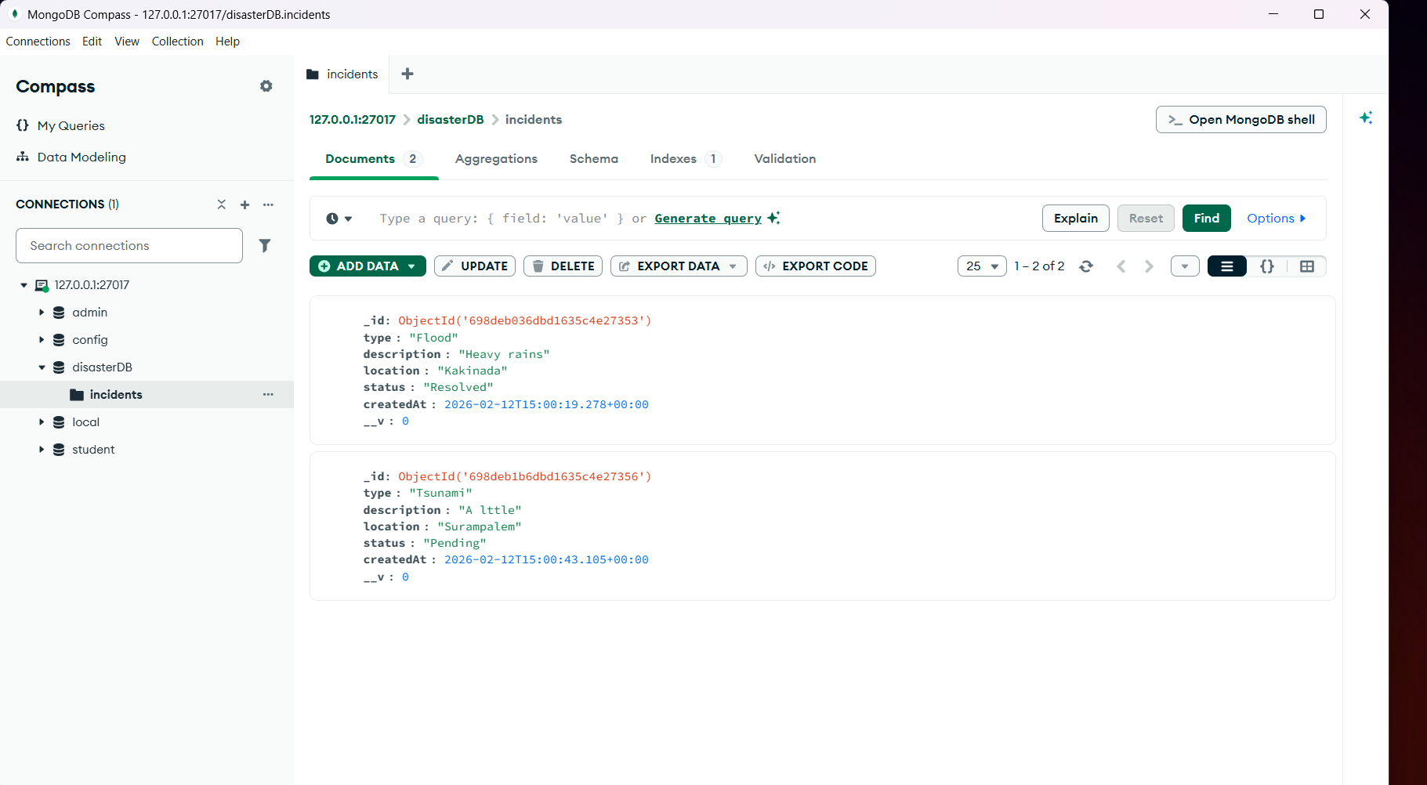

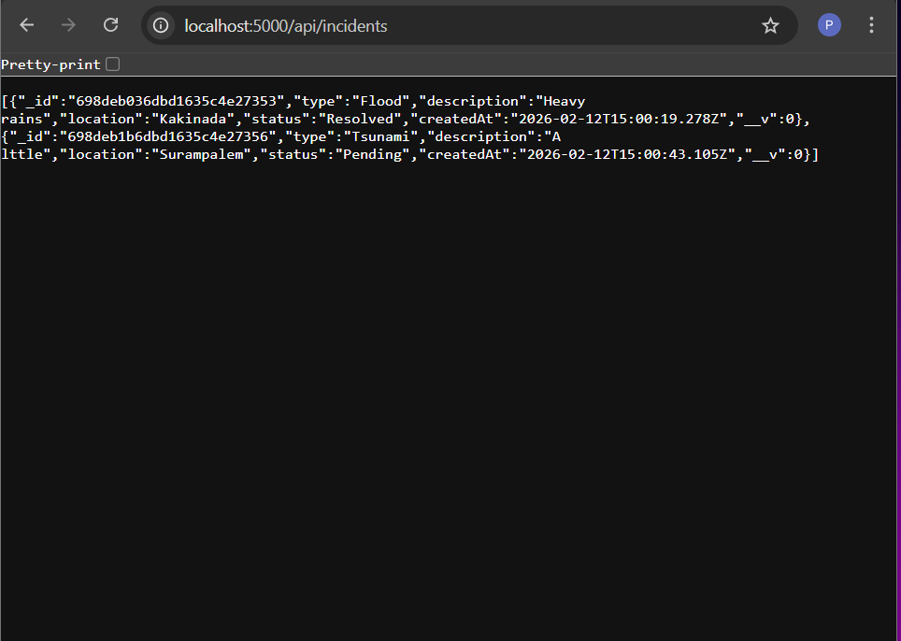

Data after deleting a record and marked as resolved for another record:
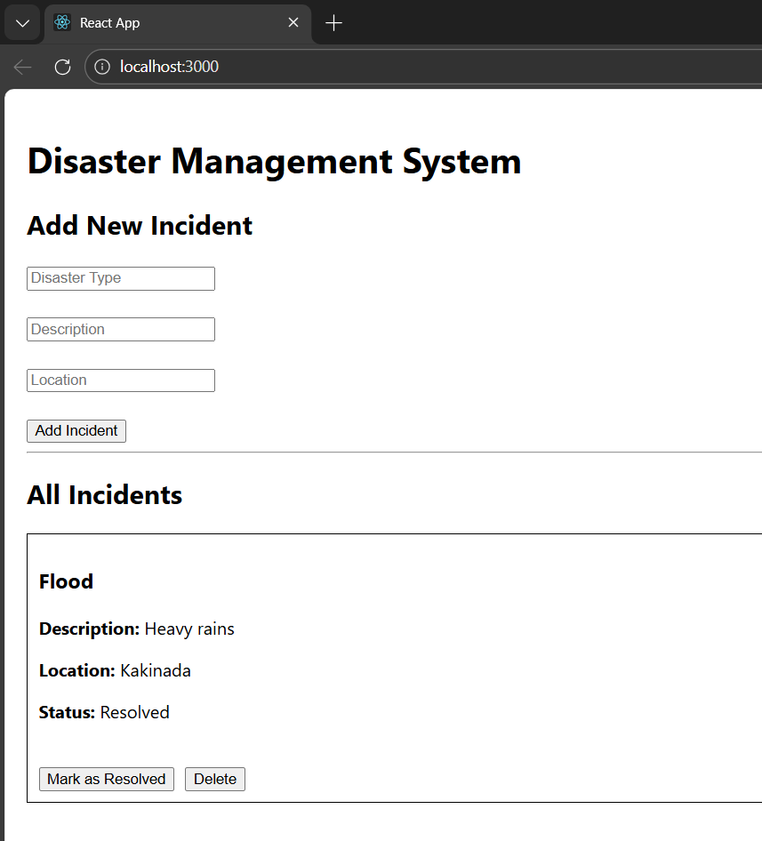

Conclusion
The Disaster Management & Emergency Alert System built using the MERN stack provides a digital platform for real-time incident reporting and management.
It includes:
• Secure authentication
• Incident reporting and tracking
• Authority monitoring
By using React, Node.js, Express, and MongoDB, the system ensures modern architecture, flexible data storage, and scalability.
This project demonstrates a practical implementation of a full-stack disaster management application.

